**Social Media Content for Kids**

Kids’ eyes are more vulnerable than adults’ eyes because they are not fully developed. Help protect your kids’ eyes from UV and harmful blue light with Transitions® lenses.

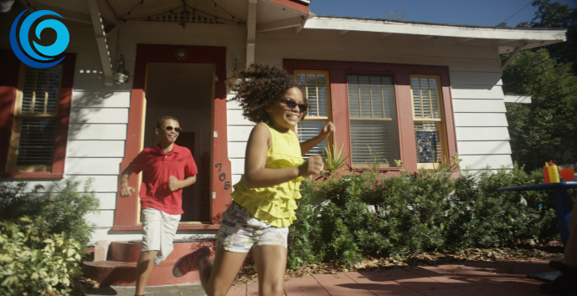

Three in four kids spend 2+ hours in front of a digital device. Try Transitions® lenses to help protect your kids’ eyes from the sun, the screen and everything in between.

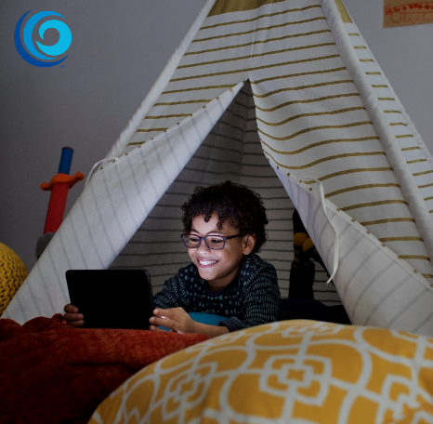

Not only do Transitions® lenses protect against UV and harmful blue light while remaining clear indoors - kids prefer them to clear lenses 9 times out of 10. Give your kids the protection they need with the lenses they love.

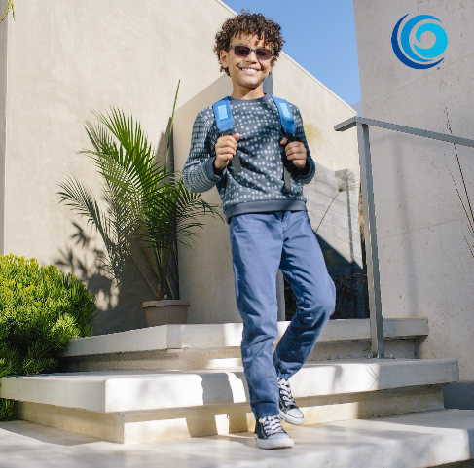

80% of learning in the first 12 years of a child is with their eyes. This alone tells us how critical vision is. (Source Vision Council)

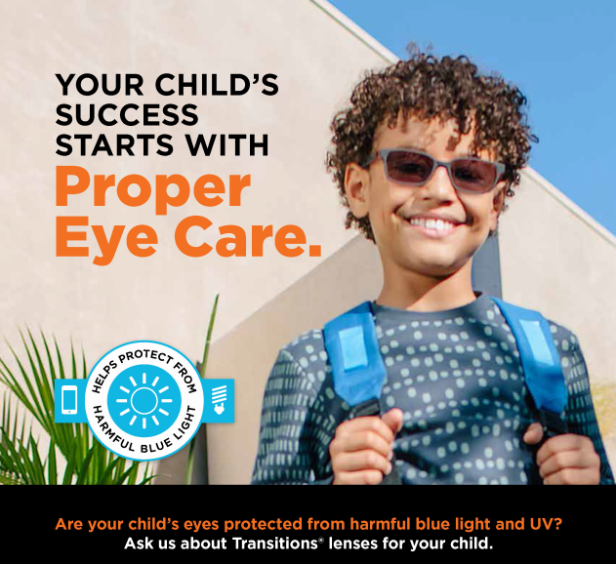

6 out of 10 children in Canada experiencing reading difficulties have uncorrected or undetected vision problems. (Source National Coalition for Vision Health)

Fewer than 14% of children in Canada under the age of 6 have had a comprehensive eye exam. (Source National Coalition for Vision Health) Vision is critical for learning and development. Make sure the kids you know have had an exam.

Kids don’t always know they are experiencing a vision problem. Create a series of posts on the symptoms to watch for:

1. While it is myth that sitting too close to the TV will ruin your eyes, this habit could be a sign of a vision problem.
2. Yes, children do often rub their eyes when they are tired or upset. But if your child is rubbing their eyes while trying to concentrate on something, or while being active, it could mean that they a vision problem.
3. When kids learn to read, they’ll often use their finger to track which word they are on. But eventually they should be able to focus and not lose their place. Losing place while reading or using a finger to guide eyes when reading could be a sign of a vision problem.
4. Children with photophobia, or extreme sensitivity to light, can develop headaches and nausea. The right lenses can help. Ask about Transitions® lenses for your kids.
5. Frequently closing one eye could indicate a refractive or binocular vision problem that interferes with the ability of the two eyes to work together as a team. If you notice this habit make sure the child gets an eye exam.
6. If a child is having a hard time seeing what their teacher writes on the board because of poor vision, they may not tell you about it. As a result their grades can suffer.
7. Digital eye strain is common among children who are frequent users of computers or other digital devices. The right lenses can help.
8. Teachers - be on the lookout for students who have to squint or tilt their heads to see the board. If you notice this habit make sure the child gets an eye exam.